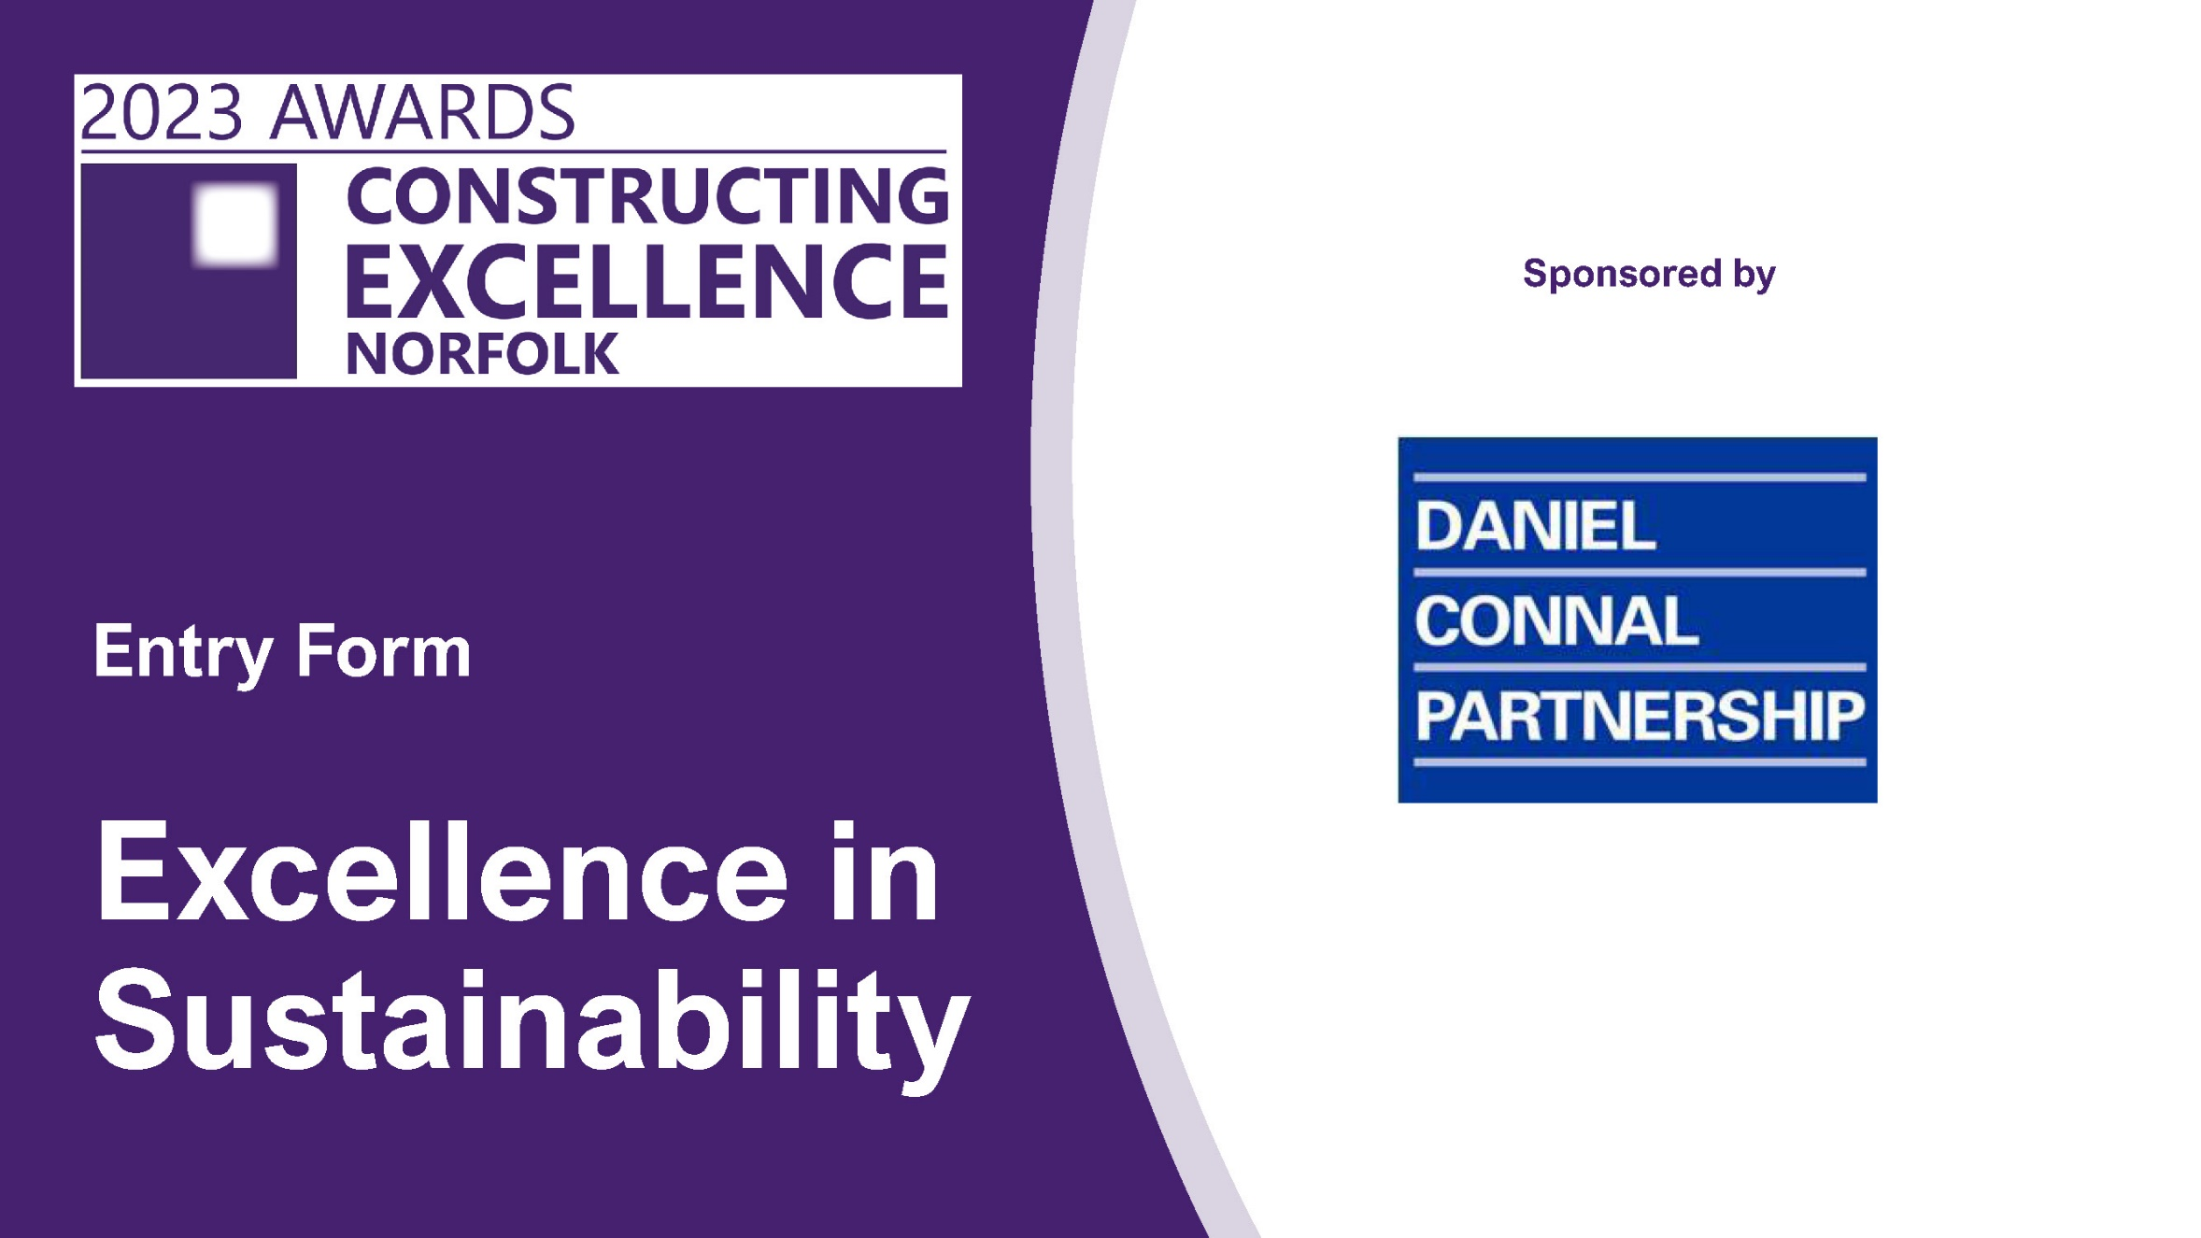

Excellence in Sustainability

This category will demonstrate the best in overall Excellence in Sustainability
The winner of this category will be put forward to one of three National Constructing Excellence Awards categories.

Conservation and Regeneration
Exemplary projects will demonstrate:
      - Evidence of research and investigation into replacing, repairing, and matching traditional methods and materials encountered with evaluation of alternative options.
      - Choice of appropriate procurement that reflects the risks in such work.
      - Application of well-considered and sympathetic technical solutions, both traditional and innovative.
      - Delivery of customer satisfying quality and enduring outcomes.
      - A clear commitment to the development of heritage skills and training opportunities to sustain heritage related works.

Net zero carbon
Exemplary projects will demonstrate:
      - Reduction in greenhouse gas and carbon dioxide emissions through design and construction measures, leading to reductions both in the build and operation phases of assets.
      - Waste and carbon emissions reduction during construction, through design and construction innovation.
      - Economic feasibility and sustainable commercial viability and their long-term impact.
      - Construction having a social value impact on its neighbouring business, residential, educational, and voluntary communities so that the industry’s image is improved.
      - Assets which evidence their performance matches or exceeds the design modelling and ratings.

Value
Exemplary projects will demonstrate:
      - Placed value for owners and/or users as a key driver throughout both the design and the construction process.
      - Increased value for owners and/or users and helped them achieve better outcomes.
      - Been able to quantify the anticipated benefits from the point of view of the owners and/or users, i.e., the balance of expenditure on design, construction and operation compared with the value of outcomes derived by owners and/or users.
      - Benchmarked their performance and results against others to evidence their achievements. These KPIs and benchmarks may be forecast or proven in use.
      - How the subject of their submission has delivered lessons for sharing and impacts on their team, their organisation and the wider industry and/or the owners and end users, e.g., addressing fuel poverty, reducing time in health care, higher education results, etc.

Excellence in Sustainability

Check list!

Your entry should consist of:

- Completed entry form – this is the only document used in the judging process.
- Please do not exceed the word count – captions are not included in word count.
- Charts and photos should be embedded in the word document where possible.
- You can submit as many photos as you like. Please use high resolution images (print quality).
- Please note that logos and images are used for publicity purposes.
- To enable entries to be uploaded onto our website, the document when saved as a pdf should be no more than 2mb.
- Submissions should be made as soon as possible and by Friday 17th March 2023 to norfolkconstructingexcellence@gmail.com

SECTION 1: The applicant’s details
Name
Organisation
E-mail
Telephone
Address
Postcode
Please state your sub-category for the National Constructing Excellence Awards here:

SECTION 2: The submission
Brief description of the project/approach

(Maximum 500 words)
Against your selected sub-category, detail your response to the highlighted areas suggested to be covered

(Maximum 750 words)
What makes your entry for your selected category stand out above others and worthy of the award

(Maximum 250 words)

