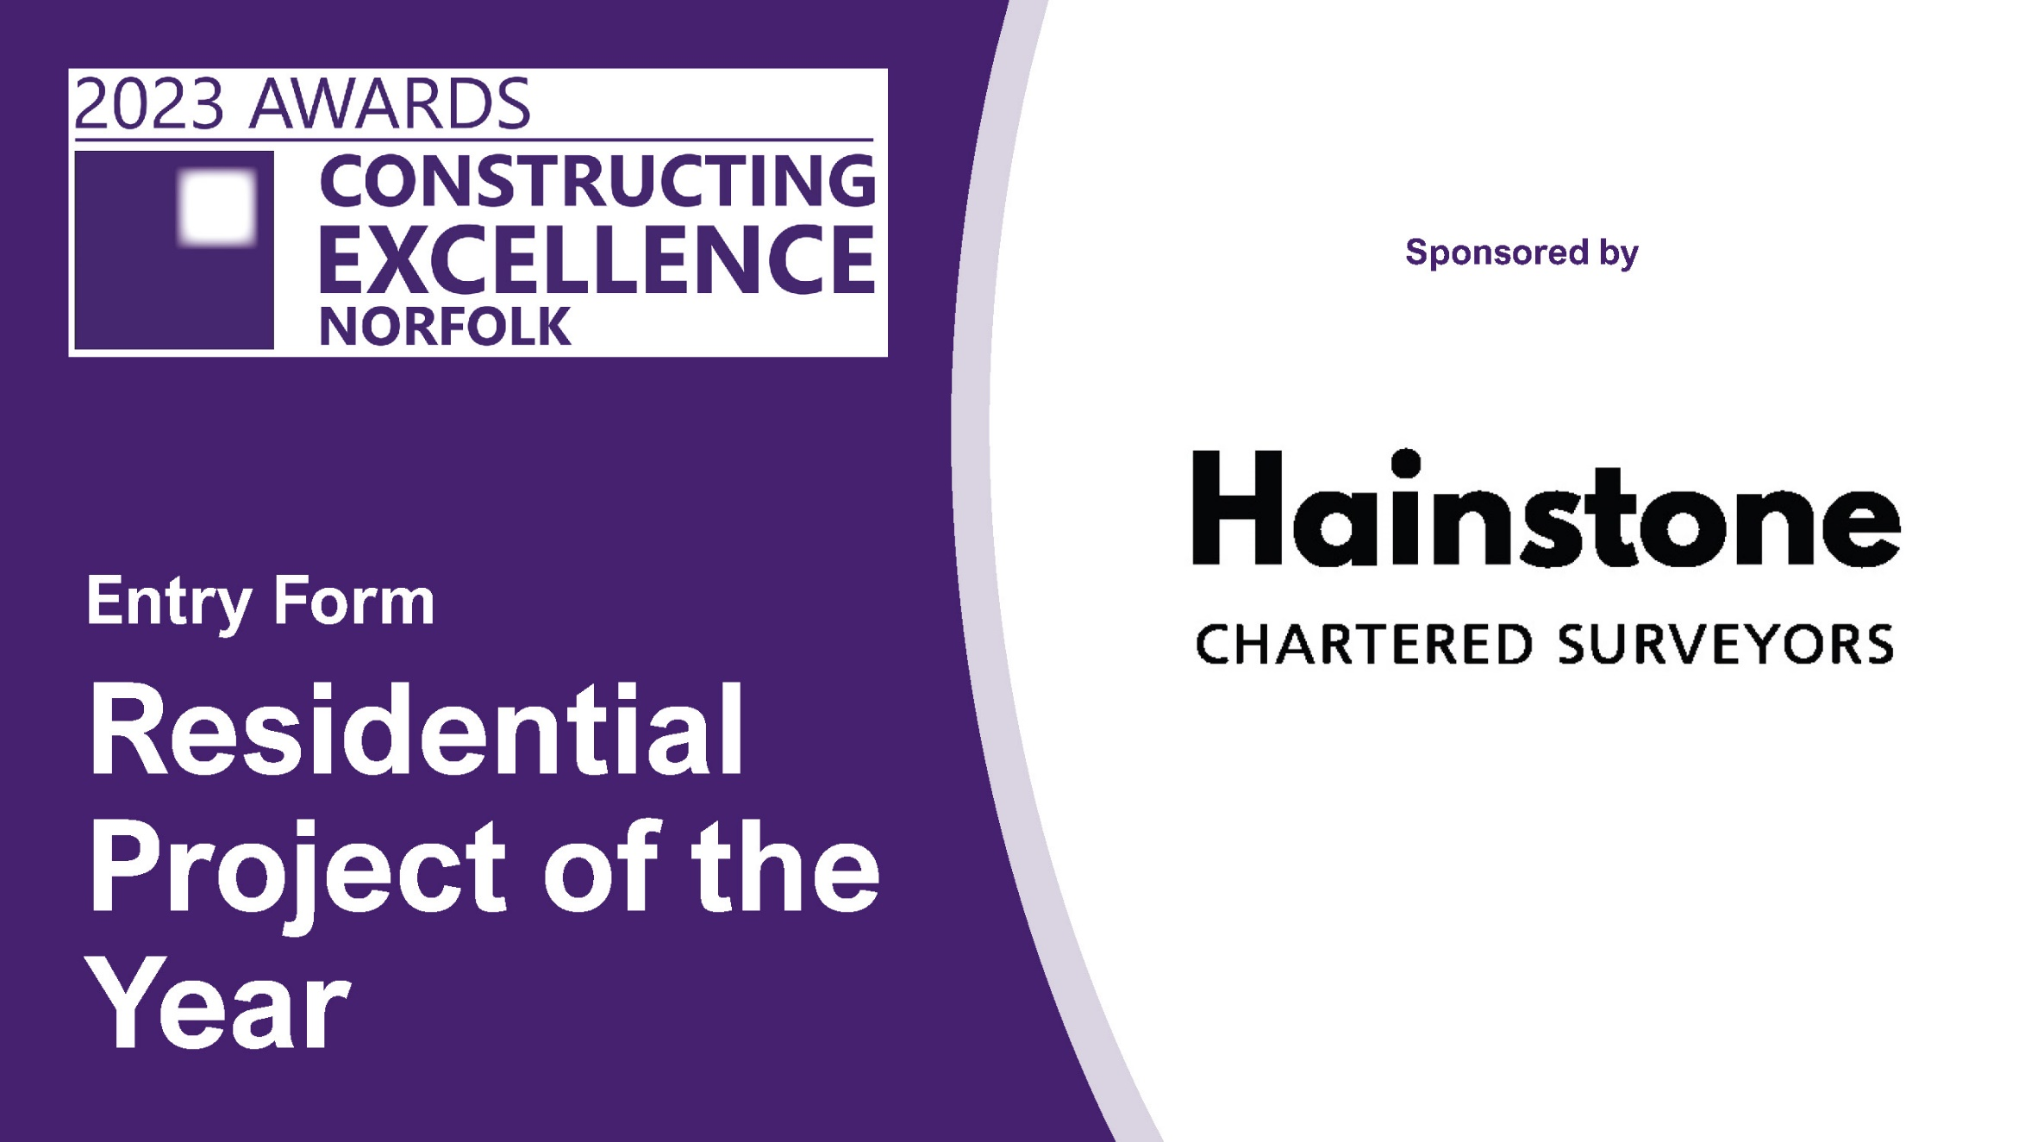

Residential Project of the Year
This category will demonstrate the best in class of overall Residential Project of the year
The winners of this category will be put forward to the National Constructing Excellence Award.

The Residential Project of the Year Award is special because the winner will be able to demonstrate excellence across all the themes in all categories within the NCEC Awards. To recap we are looking for evidence of:

- Outstanding business practice
- Attention to health, safety, and wellbeing
- Focus on People and their development
- Innovation and transformation
- Offsite construction and modern methods of construction
- Digital adoption and innovation
- Contribution to sustainability and net zero targets
- Value for money
- Conservation, preservation, and rejuvenation
- An outstanding client
- Best practice in integration and collaboration
- Outstanding leadership in the industry

Project of the Year

Check list!

Your entry should consist of:

- Completed entry form – this is the only document used in the judging process.
- Please do not exceed the word count – captions are not included in word count.
- Charts and photos should be embedded in the word document where possible.
- You can submit as many photos as you like. Please use high resolution images (print quality).
- Please note that logos and images are used for publicity purposes.
- To enable entries to be uploaded onto our website, the document when saved as a pdf should be no more than 2mb.
- Submissions should be made as soon as possible and by Friday 17th March 2023 to norfolkconstructingexcellence@gmail.com

SECTION 1: The applicant’s details
Name
Organisation
E-mail
Telephone
Address
Postcode
Please state your sub-category for the National Constructing Excellence Awards here:

SECTION 2: The submission
Project Name
Brief description of the project

(Maximum 500 words)
How does this project demonstrate complete excellence against the criteria listed

(Maximum 750 words)
What makes your entry for your selected category stand out above others and worthy of the award

(Maximum 250 words)

