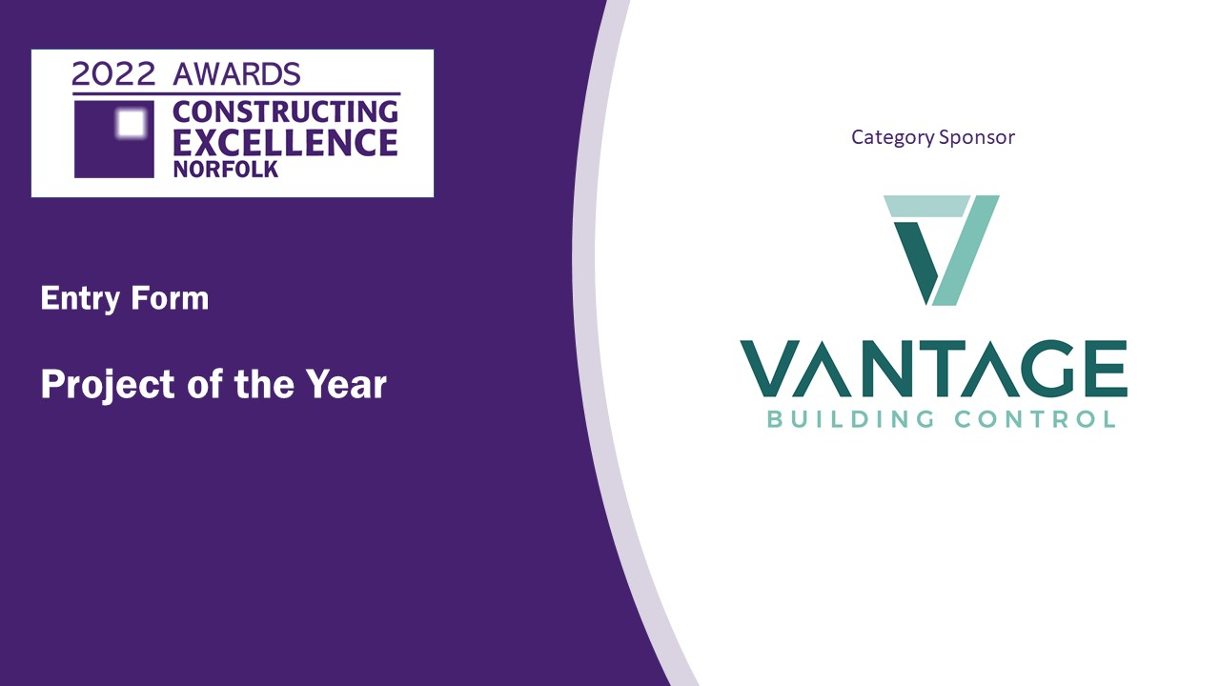

The Project of the Year Award is special because the winner will be able to demonstrate excellence across all the themes in all categories within the NCEC Awards. To recap we are looking for evidence of:

- Outstanding business practice
- Attention to health, safety, and wellbeing
- Focus on People and their development
- Innovation and transformation
- Offsite construction and modern methods of construction
- Digital adoption and innovation
- Contribution to sustainability and net zero targets
- Value for money
- Conservation, preservation, and rejuvenation
- An outstanding client
- Best practice in integration and collaboration
- Outstanding leadership in the industry

Project of the year

Check list:
Your entry should consist of:
- Completed entry form – this is the only document used in the judging process
- Please do not exceed the word count – captions are not included in word count
- Charts and photos should be embedded in the word document where possible
- You can submit as many photos as you like. Please use high resolution images (print quality)
- Please note that logos and images are used for publicity purposes
- To enable entries to be uploaded onto our website, the document when saved as a pdf should be no more than 2mb
- Submissions should be made as soon as possible and by Friday 18th March 2022 to teresajrand@gmail.com

SECTION 1: Your details
Name
Organisation
E-mail
Telephone
Address
Postcode

SECTION 2: Your submission
Project Name
Why is your project excellent?
(Maximum 250 words)

Why is your project important to this region?
(Maximum 250 words)
Why should your project win this category?
(Maximum 250 words)

